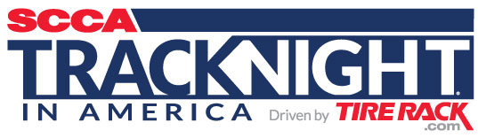

SCCA® Track Night in America® Driven by Tire Rack
Fast Facts

- SCCA Track Night in America Driven by Tire Rack is the fastest way for automotive enthusiasts to get on a race circuit. The very popular program was created as a non-competitive, no-stress, entertaining, easy and inexpensive way for nearly anyone who loves cars or motorsports to have a weeknight adventure. No previous on-track experience required.

- Realizing that traditional road courses have always been a bit of a secret society, the SCCA created Track Night in America as a way to remove the mystery around such facilities. The goal is to eliminate hurdles that keep people from enjoying local racing circuits and open the doors so everyone can come and play.

- 2017 is the third year the Sports Car Club of America® (SCCA) has conducted this program, which was developed by the SCCA’s Experiential Programs Dept. Events are rain or shine (with some exceptions).

- SCCA Track Night in America will visit more than 25 facilities around the U.S. in 2017 from March through September. Events usually run from 4pm to 8pm on weekdays, leaving weekends free for other obligations. Generally, each participating race circuit will host one Track Night in America event every month.

- The cost is never more than $150 for each entrant seeking time on track, and admission is free for those wishing to just hang out and enjoy the festivities or display cherished rides. SCCA membership is not required for Track Night in America events.

- Entrants must be at least 18 years old with a valid driver’s license, and have access to an approved helmet and street car in good working condition. (No race cars permitted!)

- Participants are divided into three categories: Novice, Intermediate or Advanced. Each group has three 20-minute sessions on track, and professional SCCA instructors and staff are on hand to provide guidance.

- A leisurely parade lap session is offered during events for attendees not registered for the full on-track experience.

- People can learn more or reserve a spot by visiting www.TrackNightinAmerica.com. Space is limited for each event.

- Additional media materials -- including press releases, full schedules and logos -- can be found at http://www.tracknightinamerica.com/pages/media-kit.

- Please direct media inquiries to:
Jim Llewellyn, PR Manager
Sports Car Club of America
323-810-7685, JimL@SCCA.com

